Model | Connections | Pressure  (Kpa) | Discharg  3  e(m /h) | Height  (m) | Diameter  (m)
ZWT65 | 2 1/2" | 70-200 | 12-18 | 3-10 | parabola  or radial
ZWT50 | 2" | 70-200 | 6-8 | 3-8 | parabola  or radial
ZWT40 | 1 1/2" | 70-150 | 4-6 | 3-8 | parabola  or radial
ZWT25 | 1" | 50-150 | 3-4 | 3-8 | parabola  or radial
ZWT20 | 3/4"(valve) | 50-150 | 1.5-3 | 1-8 | parabola  or radial
ZWT15 | 1/2"(valve) | 50-150 | 0.5-1.5 | 1-6 | parabola  or radial
ZWT10 | 3/8"(valve) | 50-150 | 0.1-1.0 | 1-4 | parabola  or radial
ZWT8 | 1/4"(valve) | 50-150 | 0.1-0.5 | 1-3 | parabola  or radial
ZWT6 | 1/8"(valve) | 30-80 | 0.05-0.4 | 1-2 | parabola  or radial
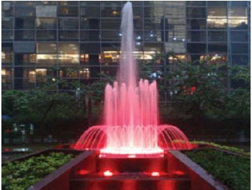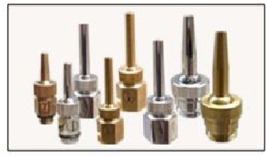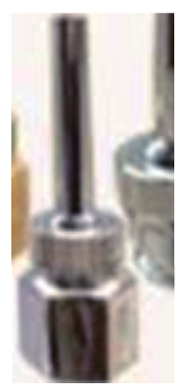

HIGH QUALITY SS304 AND BRASS FOUNTAIN NOZZLE - NEW!
HIGH QAULITY BRASS, BRASS CHROME AND SS304 FOUNTAIN NOZZLES SERIES

Thickness Single Nozzle Shooting (some with valve)

Penembakan Nozzle Tunggal Tebal (beberapa dengan katup)
Model | Connections | Pressure  (Kpa) | Discharg  3  e(m /h) | Height  (m) | Diameter  (m)
CJqT50 | 2" | 150-250 | 28-35 | 2-6M | /
CJqT40 | 1-1/2" | 150-250 | 18-25 | 2-5M | /
CJqT25 | 1" | 100-200 | 8-15.0 | 1.5-4.0 | /
CJqT20 | 3/4" | 80-150 | 4-9.0 | 1-3.0 | /
CJqT15 | 1/2" | 80-150 | 2-4.0 | 0.5-2.0 | /
Model | Connections | Pressure  (Kpa) | Discharg  3  e(m /h) | Height  (m) | Diameter  (m)
SshT50-S | 2" | 70 | 18 | 3 | 2.8
SshT40-S | 1-1/2" | 60 | 15 | 2.8 | 2.5
SshT25-S | 1" | 50 | 8 | 2.2 | 2.2
SshT20-S | 3/4" | 50 | 5 | 1.8 | 1.5
SshT15-S | 1/2" | 50 | 3 | 1.2 | 1
Model | Connections | Pressure  (Kpa) | Discharg  3  e(m /h) | Height  (m) | Diameter  (m)
SshT50-B | 2" | 70 | 18 | 3 | 2.8
SshT40-B | 1-1/2" | 60 | 15 | 2.8 | 2.5
SshT25-B | 1" | 50 | 8 | 2.2 | 2.2
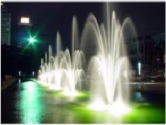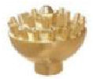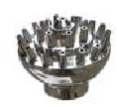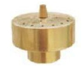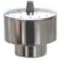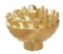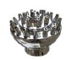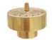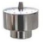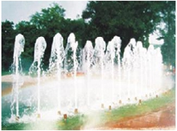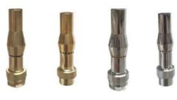

Big Fixed Blossom Nozzle
Bunga Tetap Besar Nozzle

Small Fixed Blossom Nozzle
Bunga Tetap Kecil Nozzle

Berbusa Nozzle
Frothy Nozzle

Model | Connections | Pressure  (Kpa) | Discharg  3  e(m /h) | Height  (m) | Diameter  (m)
ZJT65 | 2 1/2" | 150-280 | 40-55 | 6-10 | 0.8-1.5
ZJT50 | 2" | 150-280 | 30-45 | 5-9 | 0.6-0.8
ZJT40 | 1 1/2" | 150-280 | 20-35 | 5-7 | 0.5-0.6
ZJT25 | 1" | 100-250 | 10-15 | 3-5 | 0.3-0.5
ZJB80 | 3" | 150-280 | 50-65 | 5-9 | 0.8-1.5
ZJB65 | 2 1/2" | 150-280 | 30-45 | 5-9 | 0.6-0.8
ZJB50 | 2" | 150-280 | 20-35 | 5-7 | 0.5-0.6
ZJB40 | 1 1/2" | 100-250 | 10-15 | 3-5 | 0.3-0.5
Model | Connections | Pressure  (Kpa) | Discharg  3  e(m /h) | Height  (m) | Diameter  (m)
SKsT50 | 2“ | 70 | 22 | 3.5 | 2.8
SKsT40 | 1 1/2” | 60 | 18 | 3.0 | 2.5
SKsT25 | 1“ | 50 | 12 | 2.5 | 2.3
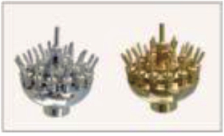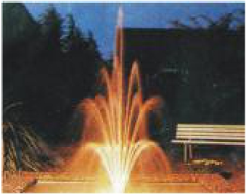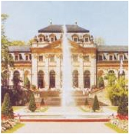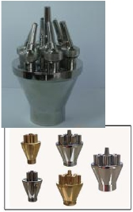

Ajustable Blossom Nozzle
Blossom yang Dapat Disesuaikan Nozzle

Concertrating Shooting Nozzle

Zjb
Berkonsentrasi Menembak Nozzle

ZJT

Model | Connections | Pressure  (Kpa) | Discharg  3  e(m /h) | Height  (m) | Diameter  (m)
SXnT40 | 1 1/2“ | 80-150 | 8-10 | 2-4 | 1.5-2.5
SXnT25 | 1” | 80-150 | 4-6 | 1-3 | 1-1.5
SXnT20 | 3/4“ | 50-80 | 2-3 | 0.8-1 | 0.6-0.8
SXnT15 | 1/2” | 50-80 | 2 | 0.8-1 | 0.5
Model | Connections | Pressure  (Kpa) | Discharg  3  e(m /h) | Height  (m) | Diameter  (m)
SFwT40 | 1 1/2" | 50-150 | 7-10 | 2-4 | parabola
SFwT25 | 1" | 50-150 | 5-8 | 2-3 | parabola
SFwT20 | 3/4" | 50-150 | 2-4 | 2-3 | parabola
Model | Connections | Pressure  (Kpa) | Discharg  3  e(m /h) | Height  (m) | Diameter  (m)
SYyB40  (NO VALVE) | 1 1/2" | 50-100 | 2.0-3.0 | 0.7-2 | 1-2.3
SYyB25  (NO VALVE) | 1" | 50-100 | 1.0-1.5 | 0.5-1.5 | 0.8-1.5

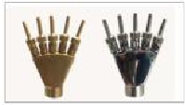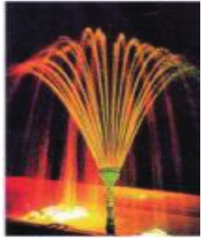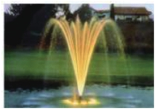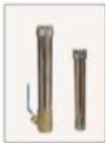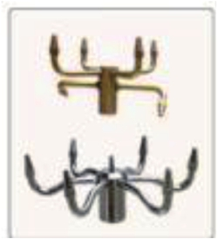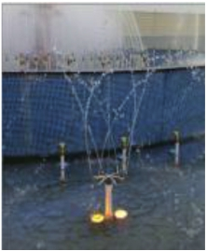

Phoenix Tale Nozzle
Kisah Phoenix Nozzle

Pirouette
Silver Tassel Nozzle (without valve)
Perak Rumbai Nozzle (tanpa katup)
Nozzle
Putaran Nozzle

Model | Connections | Pressure  (Kpa) | Discharg  3  e(m /h) | Height  (m) | Diameter  (m)
CBtT80 | 3" | 80-450 | 55-65 | 1-12 | 1-1.5
CBtT65 | 2 1/2" | 80-450 | 55-65 | 1-12 | 1-1.5
CBtT50 | 2" | 80-400 | 35-45 | 1-10 | 0.8-1.0
CBtT40 | 1 1/2" | 50-300 | 20-35 | 1-8 | 0.5-0.6
CBtT32 | 1 1/4"
CBtT25 | 1" | 40-200 | 8-12 | 1-5 | 0.2-0.3
CBtT20 | 3/4" | 40-100 | 3-5 | 1-3 | 0.2
CBtT15 | 1/2" | 40-100 | 2-4 | 1-3 | 0.15
Model | Connections | Pressure  (Kpa)
SFcT40 | 1 1/2" | 80-150
SFcT25 | 1" | 80-150
Discharg  3  e(m /h) | Height  (m) | Diameter  (m)
5-8 | 1.5-3 | 1.5-2
4-5 | 1.5-2 | 1-1.5
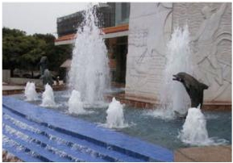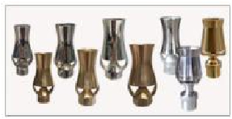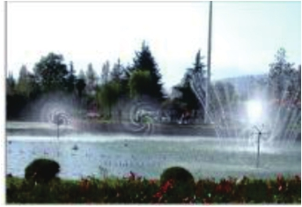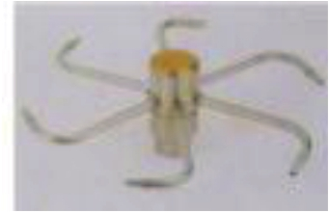

Ice Tower Nozzle

Menara Es Nozzle

Rotating Nozzle

Berputar Nozzle

Model | Connections | Pressure  (Kpa) | Discharg  3  e(m /h) | Height  (m) | Diameter  (m)
CGPT80 | 3" | 100-120 | 40-60 | 1-1.2 | 0.8-1.0
CGPT65 | 2 1/2" | 80-100 | 30-40 | 0.5-1.0 | 0.6-0.9
CGPT50 | 2" | 60-100 | 20-25 | 0.4-0.8 | 0.3-0.8
CGPT40 | 1 1/2" | 50-80 | 13-20 | 0.4-0.8 | 0.3-0.6
CGPT25 | 1" | 50-80 | 5-10 | 0.3-0.5 | 0.2-0.4
CGPT20 | 3/4" | 50-80 | 3-6 | 0.2-0.4 | 0.15-0.3
CGPT15 | 1/2" | 50-80 | 2-3 | 0.15-0.3 | 0.1-0.2
Model | Connections | Pressure  (Kpa) | Discharg  3  e(m /h) | Height  (m) | Diameter  (m)
WBtT80 | 3" | 80-450 | 55-65 | 1-12 | 1-1.5
WBtT65 | 2 1/2" | 80-450 | 55-65 | 1-12 | 1-1.5
WBtT50 | 2" | 80-400 | 35-45 | 1-10 | 0.8-1.0
WBtT40 | 1 1/2" | 50-300 | 20-35 | 1-8 | 0.5-0.6
WBtT25 | 1" | 40-200 | 8-12 | 1-5 | 0.2-0.3
WBtT20 | 3/4" | 40-100 | 3-5 | 1-3 | 0.2
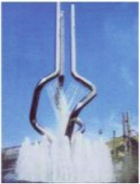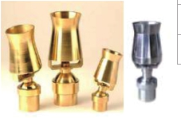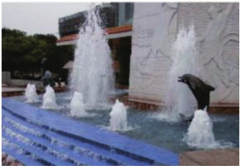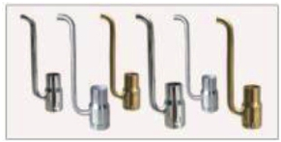

Adjustable Ice Tower Nozzle

Menara Es yang Dapat Disesuaikan Nozzle

Foam Nozzle

Busa Nozzle

Model | Connections | Pressure  (Kpa) | Discharg  3  e(m /h) | Height  (m) | Diameter  (m)
CYZB40 | 1 1/2" | 150-280 | 15-18 | 2-10 | straight or  parabola
CYZB25 | 1" | 120-200 | 8-3 | 2-8 | straight or  parabola
CYZB20 | 3/4" | 100-150 | 4-6 | 1.5-5 | straight or  parabola
CYZB15 | 1/2" | 80-150 | 2-5 | 1-3 | straight or  parabola
Model | Connections | Pressure  (Kpa) | Discharg  3  e(m /h) | Height  (m) | Diameter  (m)
CCqB50 | 2" | 80-250 | 20-25 | 2-12 | 0.6-1.2
CCqB40 | 1 1/2" | 80-200 | 15-18 | 2-7 | 0.6-1.0
CCqB25 | 1" | 60-200 | 8-15 | 1.5-5.5 | 0.5-0.8
CCqB20 | 3/4" | 60-150 | 6-8 | 0.5-4 | 0.3-0.5
CCqB15 | 1/2" | 60-150 | 6-8 | 0.5-4 | 0.3-0.5
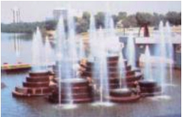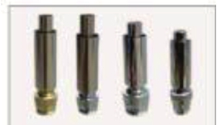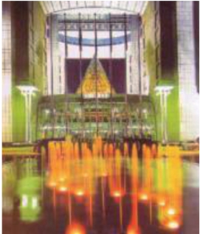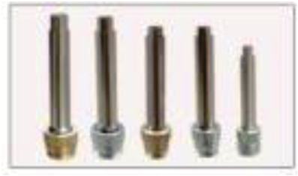

Big Air Mixed Trumpet Jet

Jet Trumpet Campuran Udara Besar Nozzle

Small Air Mixed Trumpet Jet

Jet Trumpet Campuran Udara Kecil Nozzle

Model | Connections | Pressure  (Kpa) | Discharg  3  e(m /h) | Height  (m) | Diameter  (m)
MSxT50 | 2" | 40-100 | 18-30 | 0.6-1.3 | 1.0-2.2
MSxT40 | 1 1/2" | 40-100 | 16-28 | 0.5-1.0 | 0.8-1.5
MSxT25 | 1" | 40-100 | 8-15 | 0.3-0.8 | 0.6-1.2
MSxT20 | 3/4" | 60 | 3-4 | 0.2-0.6 | 0.4-0.8
Model | Connections | Pressure  (Kpa)
MlbB50 | 2" | 60-80
MlbB40 | 1 1/2" | 40-60
MlbB25 | 1" | 40-60
MlbB20 | 3/4" | 30-40
MlbB15 | 1/2" | 30-40
Discharg  3  e(m /h) | Height  (m) | Diameter  (m)
8 | 0.60 | 1.3
5 | 0.40 | 1.0
3 | 0.33 | 0.6
2 | 0.28 | 0.5
1 | 0.28 | 0.3
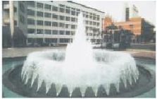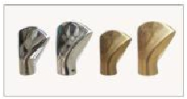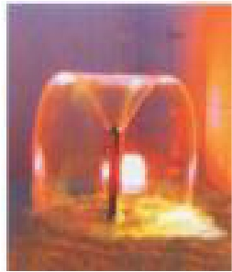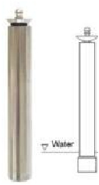

Fan Nozzle

Kipas Nozzle

Trumpet Nozzle

Terompet Nozzle

Model | Connections | Pressure  (Kpa) | Discharg  3  e(m /h) | Height  (m) | Diameter  (m)
MMgB100 | 4" | 680MM H
MMgB80 | 3" | 600MM H
MMgB60 | 2.5" | 500MM H
MMgB50 | 2" | 40-80 | 6 | 0.50 | 1.2
MMgB40 | 1 1/2" | 40-60 | 3 | 0.40 | 1.0
MMgB25 | 1" | 40-60 | 2 | 0.33 | 0.6
MMgB20 | 3/4" | 30-40 | 1.5 | 0.28 | 0.5
MMgB15 | 1/2" | 30-40 | 1 | 0.28 | 0.3
Discharg  3  e(m /h) | Height  (m) | Diameter  (m)
65 | 2.3 | 2.0
48 | 2.0 | 1.8
25 | 1.8 | 1.2
18 | 1.5 | 0.8
15 | 1.0 | 0.6
Model | Connec ons | Pressure  (Kpa)
QJB80 | 3“ | 100-150
QJB65 | 2 1/2” | 100-150
QJB50 | 2“ | 100-150
QJB40 | 1 1/2” | 80-100
QJB40 | 1 1/2“ | 80-100
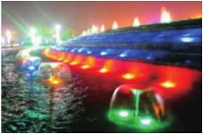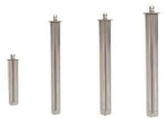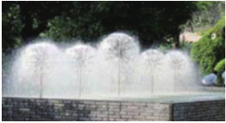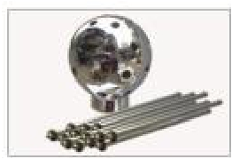

Jamur Nozzle
Mushroom Nozzle

Crystall Ball Nozzle

Bola kristal Nozzle

Model | Connections | Pressure  (Kpa) | Height  (m) | Diameter  (m)
ZCGT150 | 6" | 650-820 | 20-30 | 1.5-2.3
ZCGT100 | 4" | 380-500 | 15-25 | 1-1.5
Model | Connections | Pressure  (Kpa)
QJbB80 | 3“ | 80-100
QJbB65 | 2 1/2” | 80-100
QJbB50 | 2“ | 80-100
QJbB40 | 1 1/2” | 80-100
QJbB40 | 1 1/2“ | 60-80
Discharg  3  e(m /h) | Height  (m) | Diameter  (m)
35 | 1.2 | 2.0
25 | 1.0 | 1.8
15 | 0.8 | 1.0
10 | 0.7 | 0.8
8 | 0.5 | 0.6
ZCGT100 | 4" | 380-500 | 15-25 | 1-1.5
ZCGT80 | 3" | 300-380 | 15-25 | 0.8-1.2
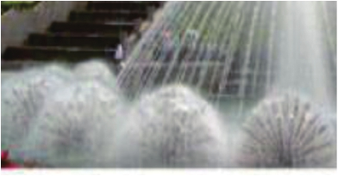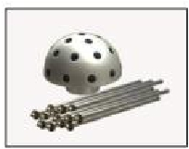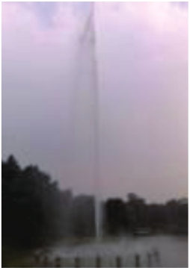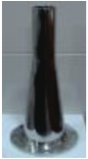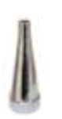

Hemisphere
Crystal Nozzle
Hemisphere Crystal Nozzle

Extral- High Spray Nozzle
Nozzle Semprot Ekstra Tinggi

Model | Connections | Pressure  (Kpa) | Discharg  3  e(m /h) | Height  (m) | Diameter  (m)
FRIbB40 | 1 1/2" | 50-100 | 3-8 | 1-2.5 | 1.0
FRIbB25 | 1" | 50-100 | 3-5 | 0.8-1.8 | 0.6
FRIbB20 | 3/4" | 50-80 | 2-3 | 0.6-1.5 | 0.5
FYgB40 | 1 1/2" | 50-150 | 6-8 | 1-2.5 | 1-2.5
FYgB25 | 1" | 50-150 | 2-6 | 0.8-2 | 1-2
FYgB15 | 1/2" | 50-80 | 1.5-2.5 | 0.6-1.5 | 1-0.8
FDgB40 | 1 1/2" | 50-100 | 4-8 | 0.8-1.2 | with valve
FDgB25 | 1" | 50-100 | 3-4 | 0.6-1.0 | without valve
FDgB20 | 3/4" | 50-80 | 2-3 | 0.6-1.5 | without valve
FDyyB40 | 1 1/2" | 50-100 | 6-8 | 1-2.5 | 1.2
FDyyB25 | 1" | 50-100 | 3-5 | 0.8-2 | 0.8
FRdyB40 | 1 1/2" | 50-100 | 6-8 | 1-3.5 | 1.3
FRdyB25 | 1" | 50-100 | 3-5 | 0.8-2.2 | 0.8
FGyB40 | 1 1/2" | 50-100 | 6-8 | 1-2 | 1.0
FGyB25 | 1" | 50-100 | 3-5 | 0.8-1.5 | 0.8

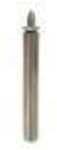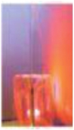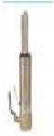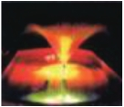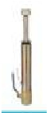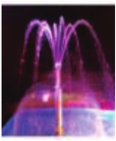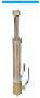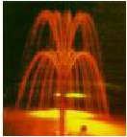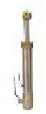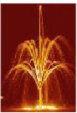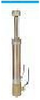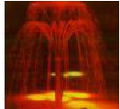

Blossom-3
Blossom-1
Blossom-2

Blossom-4

Blossom-5

Blossom-6

Model | Connections | Diameter  (m)
TByB80 | 3" CUP FOAM NOZZLES, | SS304
TByB65 | 2 1/2" CUP FOAM NOZZLES, | SS304
TByB50 | 2" CUP FOAM NOZZLE, | SS304
TByB40 | 1 1/2" CU+P FOAM NOZZLES, | SS304
TByB25 | 1" CUP FOAM NOZZLES, | SS304
TByB20 | 3/4" CUP FOAM NOZZLES, | SS304
TByB15 | 1/2" CUP FOAM NOZZLES, | SS304
Connections | Pressure  (Kpa) | Height  (m) | Diameter  (m)
5" | 380-500 | 15-25 | 1-1.5
Model | Connections
TXLT40 | 1 1/2"
TXLT25 | 1"
CUP FOAM NOZZLE-SS304
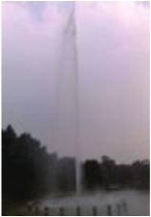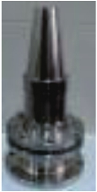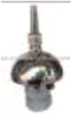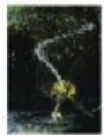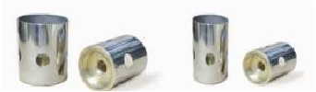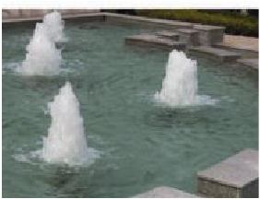

Adjustable Supper Extra-High Spray Nozzle

Rotating Single
Nozzle Semprot Super Ekstra-Tinggi Dapat Disesuaikan
Nozzle Shooting
memutar penembakan

HIGH QAULITY BRASS, BRASS CHROME AND SS304 FOUNTAIN NOZZLES - NEW SERIES
nozzle tunggal

Model | Connections
YCSM200 | DN200
YCSM150 | DN150
YCSM120 | 6" S.S304 water curtain fountains, discharge 30-60m3/h,water spray
YCSM100 | 4" S.S304 water curtain fountains, discharge 30-60m3/h,water spray
YCSM80 | 3" S.S304 water curtain fountains, discharge 20-40m3/h,water spray
YCSM50 | 2" S.S304 water curtain
SWB25 | 1"
SWB20 | 3/4"
SWB15 | 1/2"
Model | Connections
TPmB25-A | 1" CHAMPAGNE FOAM NOZZLES, SS304+plastic core
TPmB25-B | 1" CHAMPAGNE FOAM NOZZLES, SS304+SS304 core
TPmB40 | 1.5" CHAMPAGNE FOAM NOZZLES, SS304+SS304
Model | Connections
DN25 | 1"One-dimensional(180 Swing) Digital Control  Nozzle,SS304,size:DN25,DN25=1"=32MM, without control
DN40 | 1.5"One-dimensional(180o Swing) Digital Control  Nozzle,SS304,size:DN40, without control
Model | Connections
DN25 | 1"2-dimensional(360 Swing) Digital Control  Nozzle,SS304,size:DN25,DN25=1"=32MM, without control
DN40 | 1.5"2-dimensional(360 Swing) Digital Control  Nozzle,SS304,size:DN40, without control
Model | Connections
TEXT40 | 1 1/2" EUROPEAN ROTATION NOZZLE,Brass-Chrome
TEXT25 | 1 " EUROPEAN ROTATION NOZZLE,Brass-Chrome

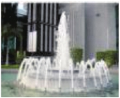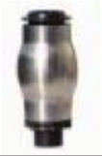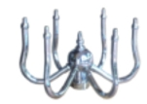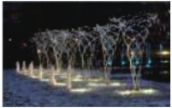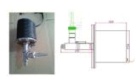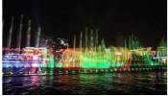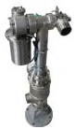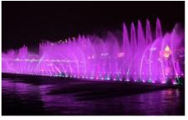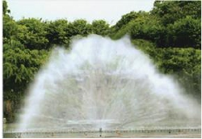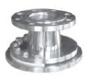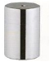

HIGH QUALITY SS304 AND BRASS FOUNTAIN NOZZLE - NEW!

CHAMPAGNE FOAM NOZZLES

NOZZLES BUSA FOAM
EUROPEAN ROTATION NOZZLES
NOZZLES ROTASI EROPA

WATER CURTAIN FOUNTAINS
1-D DIGITAL NOZZLES NOZZLES DIGITAL 1-D
2-D DIGITAL NOZZLES
NOZZLES DIGITAL 2-D
FOG NOZZLES

YCSM SWB

FOUNTAIN TIRAI AIR
KABUT NOZZLE

Model | Connections
1/2" | 1/2", 4 TIER NOZZLE,brass
3/4" | 3/4", 4 TIER NOZZLE,brass
1" | 1", 4 TIER NOZZLE,brass
1.5" | 1.5", 4 TIER NOZZLE,brass
2" | 2", 4 TIER NOZZLE,brass
Model | Connections
DN40-S | 1.5"SS 304 ADJUSTABLE FAN NOZZLE,SMALL
DN40-B | 1.5"SS 304 ADJUSTABLE FAN NOZZLE,BIG8m3/hour ow rate
Model | Connections
¾" | HIGH UQALITY SS304 ADJUST FAN NOZZLE
1" | HIGH UQALITY SS304 ADJUST FAN NOZZLE
1.5" | HIGH UQALITY SS304 ADJUST FAN NOZZLE
Model | Connections
1-1/2" | 1.5", 3 TIER NOZZLE,brass
2" | 2", 3 TIER NOZZLE,brass
Model | Connections
1-1/2" | 1.5"NEW DESIGN ADJUST BLOSSOM NOZZLE
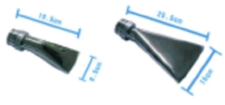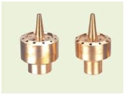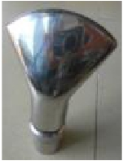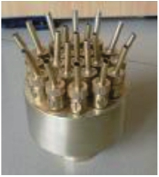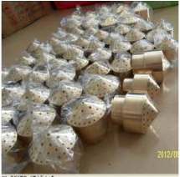

DN40-S
DN40-B

SS 304 ADJUSTABLE FAN NOZZLE

3 TIER NOZZLE-
SS 304 KIPAS KABEL DISESUAIKAN NOZZLE
SEPENUHNYA KUNINGAN

3 TIER NOZZLE-
KUALITAS TINGGI
FULLY HIGH

HIGH
QUALITY BRASS
UQALITY
SS304 ADJUST
FAN NOZZLE

KUALITAS TINGGI
MENYESUAIKAN

NEW DESIGN
KIPAS FAN
ADJUST
BLOSSOM
NOZZLE

MENYESUAIKAN
BLOSSOM NOZZLE

4 TIER NOZZLE-
SEPENUHNYA KUNINGAN

4 TIER NOZZLE-
KUALITAS TINGGI
FULLY HIGH
QUALITY BRASS

Model | specication
BG5002 | low pipe dia:DN32,built-in 3x3W RGB LED underwater  lights,ow rate:5m³/h,performance:8-10m,water  requiremet:pool water standard, Water Outlet Port  Dia:12-16mm optional (outdoor no wind require,spay  high:1.5-1.8m,span:1.5-2.2m,indoor:spay high:1.8-  2.0m,span:1.8-2.5m),0.55KW PUMP,DELIVER  HEAD12M
Model | specication
BG5003 | NEW DESIGN SMALL LAMINAR JET ,S.S.304, WATER  SPRAY SPAN:2M, WATER SPRAY HIGH:1.5M,  OUTLET DIA.:14MM, BUILT-IN 3X3W RGB LED, 4-  WIRE OUTPUT OR DMX512 OPTIONAL,WATER  FLOW RATE:4M3/H, PUMP POWER:350KW,DELIVER  HEAD:8M
Model | specication
1.5" | Double Phoenix Tales Nozzle, mady by order,1.5"connection,fully brass
2" | Double Phoenix Tales Nozzle, mady by order,2"connection,fully brass
Model | specication
3" | Special brass nozzle, mady by order,3"connection
SS304 LAMINAR JET
SS304 LAMINAR JET

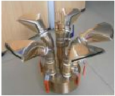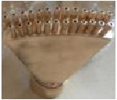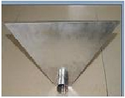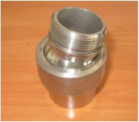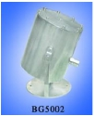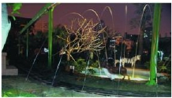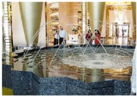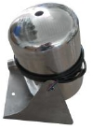NEW DESIGN
BRASS DOUBLE
PHOENIX TALES
NOZZLE

TALES PHOENIX
GANDA KUNINGAN

NEW DESIGN
BRASS DOUBLE
PHOENIX TALES

TALES PHOENIX
GANDA KUNINGAN

NEW DESIGN
SS304 WATER
CURTAIN

Tirai Air

specication

Water curtain nozzle,200MM*1.5"

Water curtain nozzle,400MM*2”

Water curtain nozzle,600MM*2"

Water curtain nozzle,800MM*2.5"
BRASS BALL
JOINT

ball joint
kuningan

specication

2" BRASS BALL JOINT MALE-FE MALE

1 1/2BRASS BALL JOINT MALE-FE MALE

1" BRASS BALL JOINT MALE-FEMALE

3/4" BRASS BALL JOINT MALE-FE MALE

1/2" BRASS BALL JOINT MALE-FE MALE

HIGH QAULITY SS304 LAMINAR JETS

Model | specication
BG5001 | ow pipe dia:DN40,built-in 3x1W high power LED  underwater lights,ow rate:6-7m³/h,performance:10-  13m,water requiremet:pool water standard, Water Outlet  Port Dia:16-22mm optional (outdoor no wind  require,spay high:2.0-2.3m,span:3.0-4.0m,indoor:spay  high:2.1-2.8m,span:4.0-5.0m),,0.55KW
Model | specication
TQBG6001 | PUMP,DELIVER HEAD12M  1. 3x3W RGB light(built in transformer).  2.Stepper motor  3. 10m cable for jumping jet control, and 10m cable foer  light control.  4:CUTTER,Water Outlet Port Dia:16-22mm optional  (outdoor no wind require,spay high:2.0-2.3m,span:3.0-  4.0m,indoor:spay high:2.1-2.8m,span:4.0-  5.0m),,0.55KW PUMP,DELIVER HEAD12M
Model | specication
TQBG6002 | including  1. 3x3W RGB light(built in transformer).  2.Stepper motor  3. 10m cable for jumping jet control, and 10m cable foer light  control.  4:CUTTER, Water Outlet Port Dia:12-16mm optional  ,(outdoor no wind require,spay high:1.5-1.8m,span:1.5-  2.2m,indoor:spay high:1.8-2.0m,span:1.8-2.5m),,0.55KW
Model | specication
BG5004 | PUMP,DELIVER HEAD12M  NEW DESIGN BALL NOZLE,S.S.304,WATER  SPRAY HIGH:1.5-1.8M OR 1.5-2.2M,W A TER SPRAY  SPAN:1.5-2.2M OR 3-4M.DELIVER HEAD12M
SS304 JUMPING JETS MELOMPAT JET

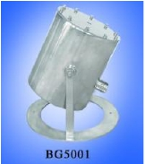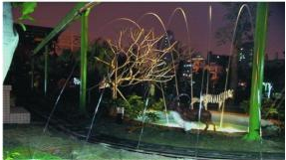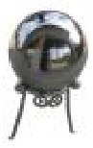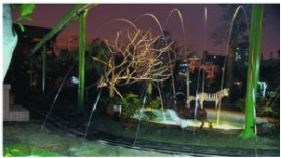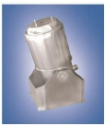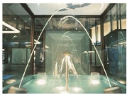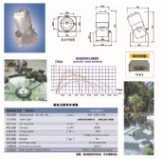

SS304 LAMINAR JET

SS304
LAMINAR JET

